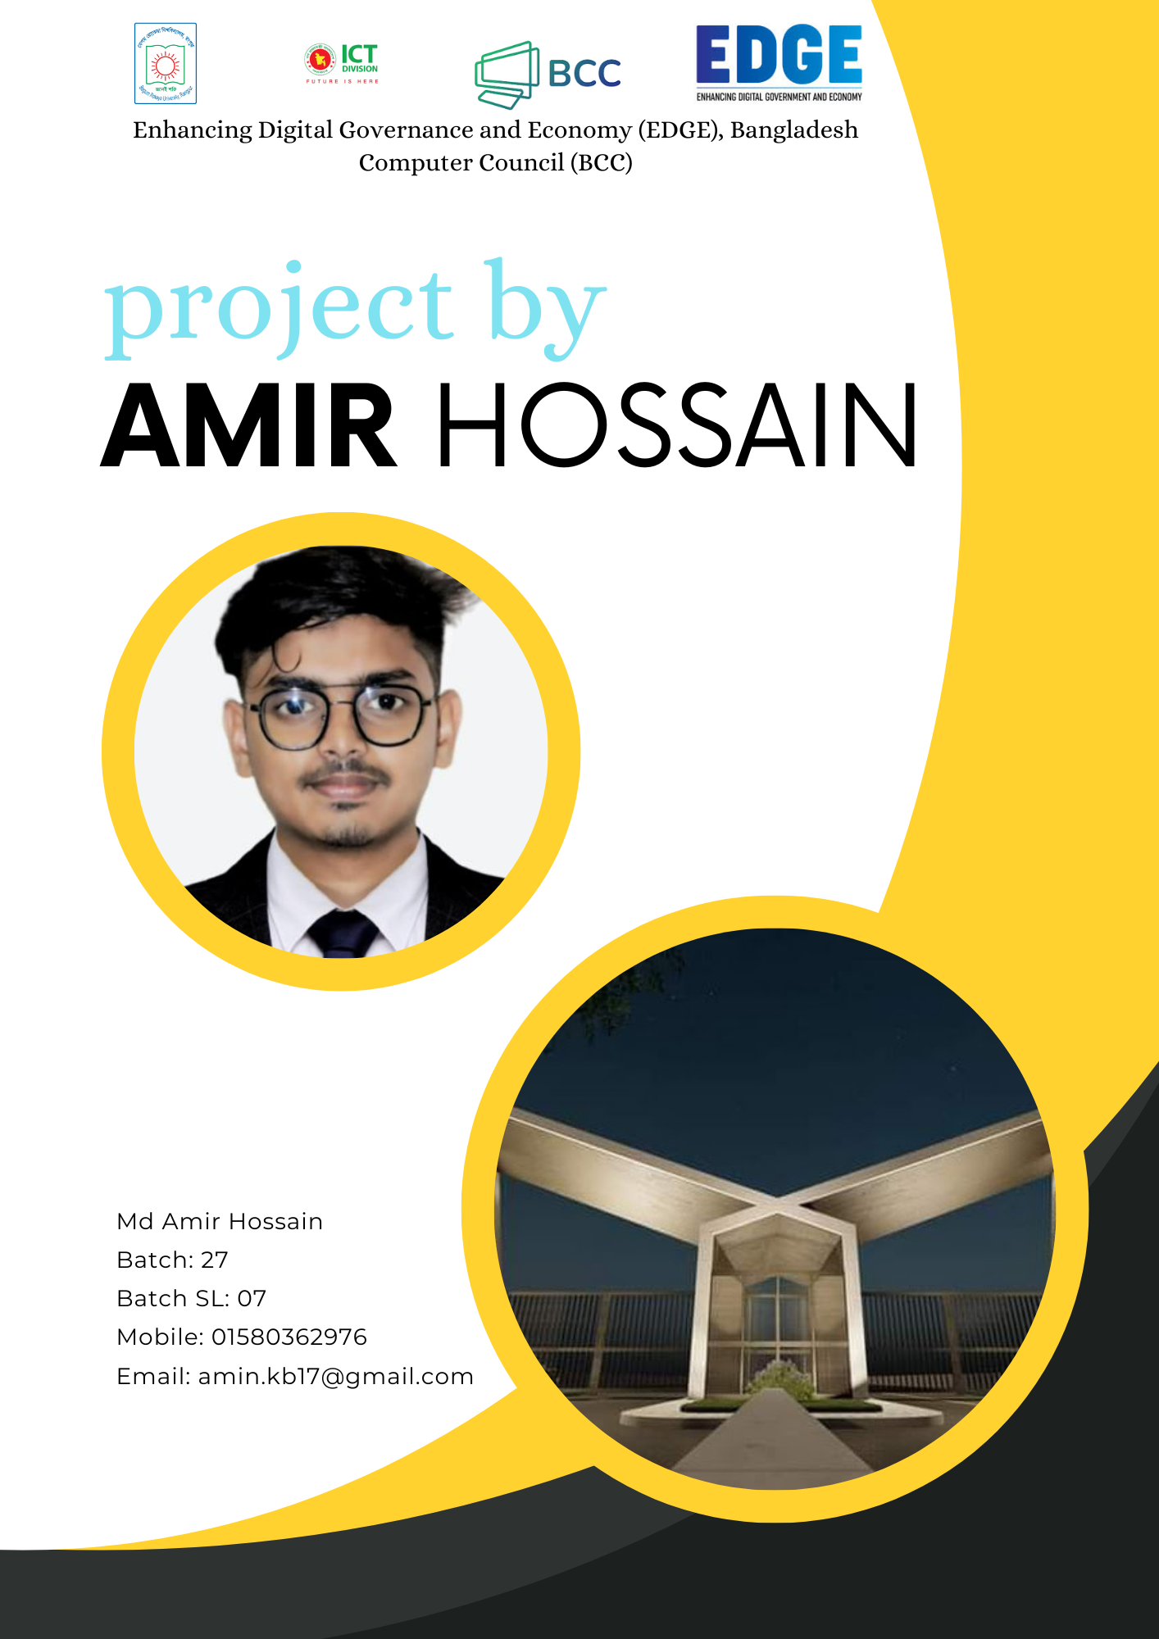

**Enhancing Digital Governance and Economy (EDGE), Bangladesh Computer Council (BCC)**

**PROJECT BY MD AMIR HOSSAIN**

**Project title:** About Begum Rokeya University, Rangpur

**Name: Md Amir Hossain**

**Batch: 27**

**Batch SL: 07**

**Mobile: 01580362976**

**Email: amin.kb17@gmail.com**

Content

Introduction 3

**Campus** 5

History 6

**Administration** 6

**Academics** 7

**Faculties and departments** 9

**The number of students of Begum Rokeya University, Rangpur** 10

**Admission** 12

**Central Library and Information Center** 13

**Institute** 13

**Residential halls** 13

**List of vice-chancellors** 14

**References** 15

# **Introduction**

**Begum Rokeya University, Rangpur** (Bengali: বেগম রোকেয়া বিশ্ববিদ্যালয়, রংপুর) (abbreviated as **BRUR**), formerly **Rangpur University**, is a public research university in Rangpur, Bangladesh. Founded in 2008, it is the only generally categorized university in Rangpur Division and the second public university in the region. It was named after the feminist writer and social worker Begum Rokeya.

|  |  |
| --- | --- |
| **Former names** | Rangpur University |
| **Motto** | জ্ঞানই শক্তি |
| **Motto in English** | Knowledge is Power |
| **Type** | Public |
| **Established** | October 12, 2008; 16 years ago |
| **Budget** | ৳ 71.44 cr (2024-25) |
| **Chancellor** | President Mohammed Shahabuddin |
| **Vice-Chancellor** | *Professor Dr. Md. Showkat Ali* |
| **Academic staff** | 199 |
| **Administrative staff** | 131 |
| **Students** | 7,050 |
| **Undergraduates** | 5,982 |
| **Postgraduates** | 1,068 |
| **Location** | Rangpur  ,  Bangladesh  25.7179°N 89.2592°E |
| **Campus** | Urban, 75 acres (30 ha) |
| **Language** | Bengali, English |
| **Affiliations** | University Grants Commission of Bangladesh |
| **Website** | brur.ac.bd |

## **Campus**

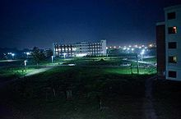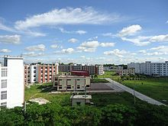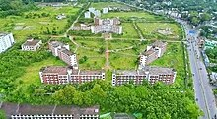The university is between Rangpur Cadet College and Carmichael College in Rangpur. It covers an area of 75 acres (30 ha). The university has constructed four academic buildings and started classes in August 2011 on the main campus. Currently, the university has 22 departments and almost 7,000 students. It contains three student halls (two male and one female). There is a library and a cafeteria on the campus.

Rear View of Campus, Begum Rokeya University, Rangpur

Bird’s-eye view of BRUR

Campus of Begum Rokeya University at Night, Rangpur

### History

Since 1947, a university in this region has been a long-cherished dream. Popular demand for a kind of university that can reach out to a large number of students desiring higher education in this vast region has always been intensely felt but has never been fulfilled. In 2001, the then Prime Minister, Sheikh Hasina, laid the foundations of Rangpur University of Science and Technology. However, later on, the establishment was canceled.

It was not until August 2007 when Fakhruddin Ahmed, chief advisor of the Caretaker Government, agreed in principle to establish a full-fledged university in Rangpur. Fakhruddin Ahmad, in a historic cabinet meeting held in Rangpur on 2 February 2008, decided to establish a university in Rangpur. The Rangpur University Ordinance was approved by the cabinet on 15 June 2008. M. Lutfar Rahman was appointed the first vice-chancellor on 20 October 2008. Two days later Hossain Zillur Rahman, the then education and commerce advisor to the Caretaker Government formally inaugurated the university.

#### **Administration**

* Vice-Chancellor (VC): *Professor Dr. Md. Showkat Ali*
* Pro Vice-Chancellor: *Professor Dr. Sarifa Salowa Dina*
* Treasurer: *Professor Dr. Mojib Uddin Ahmed*

**Administrative officers**

* *Registrar: Engr. Md. Alamgir Chowdhury*
* *Assistant Registrar: Md. Khairul Islam*
* *Proctor: Dr. Md. Ferdous Rahman*
* **Provosts:**
  + *Komolesh Chandra Sarkar, Bangabandhu Sheikh Mujibur Rahman Hall*
  + *Shafiqur Rahman, Sohid Mukhtar Elahi Hall*

##### **Academics**

* 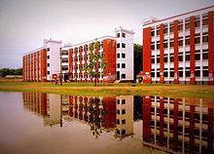**Undergraduate programs**
* **BSc (Engineering)**
* **BSc (Hons.)**
* **B.A. (Hons.)**
* **B.B.A. (Hons.)**
* **B.S.S. (Hons.)**

Academic Building 1 & 2 of Begum Rokeya University, Rangpur

* 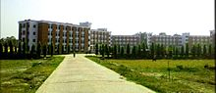**Graduate programs**
* **MSc (Engineering)**
* **MSc**
* **M.A.**
* **M.B.A.**
* **M.S.S.**

Academic Building of Begum Rokeya University, Rangpur

* 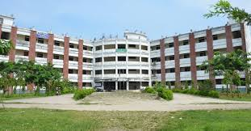**Post Graduate programs**
* **MPhil (MPhil leading to PhD)**
* **PhD**
* **Other programs**

Administration Building of BRUR

* **M.B.A. (Evening)**

###### **Faculties and departments**

**BRUR has 22 departments under six faculties.**

|  |  |
| --- | --- |
| **Faculty** | **Department** |
| **Faculty of Arts** | **Bangla** |
| **English** |
| **History and Archaeology** |
| **Faculty of Social Science** | **Economics** |
| **Sociology** |
| **Political Science** |
| **Gender and Development Studies** |
| **Mass Communication and Journalism** |
| **Public Administration** |
| **Faculty of Business Studies** | **Accounting and Information Systems** |
| **Management Studies** |
| **Marketing** |
| **Finance and Banking** |
| **Management Information Systems** |
| **Faculty of Science** | **Mathematics** |
| **Statistics** |
| **Physics** |
| **Chemistry** |
| **Faculty of Engineering & Technology**  **Faculty of Science of Science Faculty o** | **Computer Science and Engineering** |
| **Electrical and Electronic Engineering** |
| **Faculty of Life and Earth Sciences** | **Geography and Environmental Science** |
| **Disaster Management** |

**The number of students of Begum Rokeya University, Rangpur**

|  |  |
| --- | --- |
| **Programs** | **Students** |
| Graduation | 5982 |
| Post-Graduation | 1068 |
| Total Student | 7050 |

**Admission**

**BRUR enrolls undergraduate students. Students who want to get admitted need to pass and compete on the merit list in the admission test which is highly competitive. Admission tests are arranged by the university under the authority of the admission council for all faculties.**

**Statistics based on academic year 2014–15 admission:**

* **Total applicants: 90,402**
* **Total seats available: 1,258**
* **Average applicant-to-seat ratio: 72:1.**
* **Acceptance rate: 1.39%**

**Central Library and Information Center**

The Central Library and Information Center (CLIC) of Begum Rokeya University was established on 12 October 2008 to support the instructional and research programs of the university. The vice-chancellor opened all activities of CLIC on 19 November 2009.

Initially, CLIC started functioning at the temporary campus of the university (Teachers' Training College, Rangpur). It was shifted to the permanent campus on 19 March 2011. This library and information center has large reading rooms with huge resources such as books, journals, periodicals, etc. The director is Porimol Chandra Barman

**Institute**

Dr. Wazed Research and Training Institute. MPhil & PhD degrees are offered at this institute. The institute is one of the few institutes exclusively designed for MPhil and PhD programs in the country. It also offers an MPhil leading to a PhD

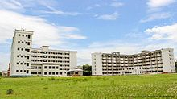 **Residential halls**

For male students

* Bangabandhu Sheikh Mujibur Rahman Hall

Male Student Halls of Begum Rokeya University, Rangpur

* Sohid Mukhtar Elahi Hall

Male Student Halls of Begum Rokeya University, Rangpur

**For female students**

* Sheikh Fazilatunnesa Mujib Hall
* Sheikh Hasina Hall (under construction)

**List of vice-chancellors**

|  |  |  |
| --- | --- | --- |
| **Name** | **From** | **To** |
| M. Lutfar Rahman | **20 October 2008** | **7 May 2009** |
| Mohammad Abdul Jalil Miah | 7 May 2009 | 5 May 2013 |
| A.K.M Nurun Nabi | 6 May 2013 | 5 May 2013 |
| Nazmul Ahsan Kalimullah | 1 June 2017 | 9 June 2021 |
| Md. Hasibur Rashid | 9 June 2021 | 10 Augst 2024 |
| Professor Dr. Showkat Ali | 18 September 2024 |  |

**References**

* 1. **^ *"৫৫ পাবলিক বিশ্ববিদ্যালয় কে কত বাজেট পাচ্ছে". thedailycampus.com. Retrieved 16 June 2024.***
  2. **^ *"Begum Rokeya University, Rangpur - Historical Outline". brur.ac.bd. Retrieved 13 December 2024.***
  3. **^ *"Begum Rokeya University begins academic activities". The Financial Express. Dhaka. Archived from the original on 1 October 2011. Retrieved 15 May 2012.***
  4. **^ *"Rangpur University Launched". Star Campus. The Daily Star. 15 April 2009.***
  5. **^ Jump up to:*a* *b* *"New Rangpur University gets VC". bdnews24.com. 20 October 2008.***
  6. **^ *"Begum Rokeya University, Rangpur - Vision and Mission". brur.ac.bd. Retrieved 27 August 2024.***
  7. **^ *"Begum Rokeya University, Rangpur - Vision and Mission". brur.ac.bd. Retrieved 27 August 2024.***
  8. **^ *"Begum Rokeya University, Rangpur - Vision and Mission". brur.ac.bd. Retrieved 27 August 2024.***
  9. **^ *"Atiur Rahman made acting proctor of BRUR". GEEBD Education Daily. Archived from the original on 21 September 2019.***
  10. **^ *বেরোবির মুখতার ইলাহী হলে নতুন প্রভোস্ট-সহকারি প্রভোস্টের যোগদান. ournewsbd.net (in Bengali). 7 August 2017.***
  11. **^ *"Lekhapora BD" বেগম রোকেয়া বিশ্ববিদ্যালয়ের ভর্তি পরীক্ষার কেন্দ্রের নাম ও ঠিকানা. Lekha Pora (in Bengali). 3 May 2015.***
  12. **^ *বেরোবি প্রশাসনের ১২ পদে নতুন মুখ [New face in 12 posts of Berobi administration]. Jago News 24 (in Bengali).***
  13. **^ *"Prof Jalil made Begum Rokeya University VC". The Daily Star. 10 May 2009. Retrieved 6 December 2016.***
  14. **^ *"Nurun Nabi new VC of Rokeya Univ". bdnews24.com. 6 May 2013.***
  15. **^ *বেগম রোকেয়া বিশ্ববিদ্যালয়ের ভাইস চ্যান্সেলর নিয়োগ আদেশ. moedu.portal.gov.bd. Retrieved 7 June 2017.***
  16. **^ *"Professor Hasibur Rashid appointed Begum Rokeya University VC". The Daily Star. 9 June 2021.***
  17. **^ *"2 more pub univ VCs resign". New Age. 10 August 2024. Retrieved 15 August 2024.***